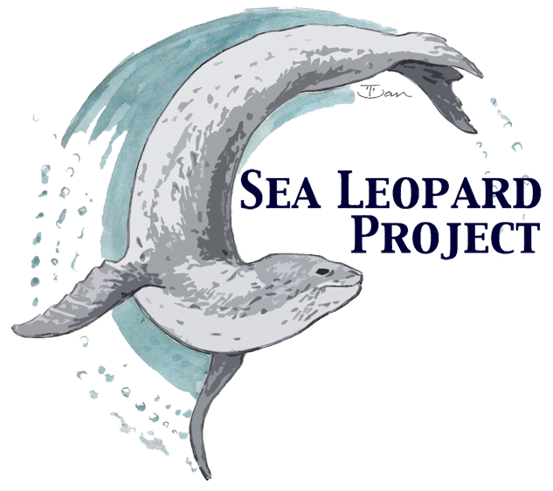

To understand the behaviour, ecology, and population dynamics of Leopard Seals on the Antarctic Peninsula in order to promote their conservation and safe human-seal interactions.

Sea Leopard Project

Founders: Lisa Trotter (www.polardive.com) and Marlynda Elstgeest (www.waterproof-expeditions.com)

This non-profit study aims to match sightings of Leopard Seals (Hydrurga leptonyx) between locations on the Antarctic Peninsula, as well as their winter habitats. We hope this study will help us learn more about population size and distribution, as well as behaviour, allowing both the scientific and tourist communities to benefit from the knowledge. We would be most grateful for any contributions to the catalogue.

We require sharp photographs or video of as many sightings of the Leopard Seal as possible, especially focusing on unusual markings.
If you have a contribution, please request a copy of this form and fill out the information below.
Thank you in advance for your assistance

Ship Name:

Operator Name:

Your Name:

Date and Time of Seal sighting (UTC - day/month/year):

General Location (e.g. Port Lockroy Antarctic Peninsula):

Precise Location, if possible (e.g., GPS Position in format S DD° MM.MMM’ if possible):

Brief description of behaviour, including distance from ship or Zodiac (e.g., feeding, laying on ice):
*A second and more detailed form is available for those who wish.

I, _______________________, understand that my photographs will only be used in conjunction with research for the Sea Leopard Project and not for commercial use.

Signature: _______________________________________________

Please keep me up to date with the Sea Leopard Project.
Name and E-mail Address:

Supported by David Barnes (British Antarctic Survey, UK) and Tracey Rogers (Univ. of New South Wales, Au)

